**Identify Activity Centers for Travel Market Basket Definition and Calculate Travel Time Cost**

This memo documents the method used to identify activity centers for travel market basket definition, and calculates monetary cost of travel time to these centers. All employment data, including those by sector group, used in this process are from Longitudinal Employer-Household Dynamics (LEHD) aggregated to TAZ. Other data, such as households and park acres, are from travel demand model data provided by Metro.

Activity centers of four trip purposes (HBW, HBS, HBR and HBO) are identified with the method proposed by Giulinao (1991): a center is defined as a continuous set of zones, each with density above some cutoff *D*, that together have at least *E* total employment and for which all the immediately adjacent zones outside the center have density below *D*. In this study, employment density is used for HBW, and sizetterms[1] density is used for HBS, HBR and HBO.

After identifying centers, travel time are calculate with two methods, which are converted into monetary cost. Then monetary cost are aggregated by weighting costs for each mode by the possibilities of using the mode.

Detailed steps are as follows:

1. Calculate employment or sizeterms density

This step calculates employment density for HBW and sizeterms density for HBR, HBS, and HBO. For HBW, employment used here is the total employment of all sectors. Sizeterms for HBR, HBS and HBO are calculated as follows:

HBSsizeterms = RetEmp +.008396*NonRet + .022126*Hhold

HBRsizeterms = TotEmp + 1.278*Hhold + 4.6833*ParkAcres

HBOsizeterms = 0.2393*Hhold + RetEmp + 0.6419*SvcEmp + 0.6109*GvtEmp

+ 06802*NonRetSvcGvt

where

RetEmp = retail trade (NAICS 44, 45, 72)

NonRet = all employment other than retail

Hhold = Number of households in attraction TAZ

TotEmp = Total employment of attraction TAZ

ParkAcres = Park acres in attraction TAZ

SvcEmp = service (NAICS 51, 54, 56, 61, 62, 71, 81)

GvtEmp = government ownership service (NAICS 92)

NonRetSvcGvt = all employment other than retail, service, and government

All processes in this step are completed in R script file: 1_cal_den.R.

2. Add data to shape file

This step adds employment density and sizeterms density data to shape file. All processes of this step is completed in 2_add_col_to_shp.R

3. Identify centers

This step identifies centers for HBW, HBS, HBR and HBO. The appropriate cutoff *D* and *E* should match the theoretical concept of centers, to be able to analyze commuting to centers, and to end with a manageable number suitable for statistical analysis. To identify appropriate cutoffs, histogram of employment or sizeterms density distribution are generated.

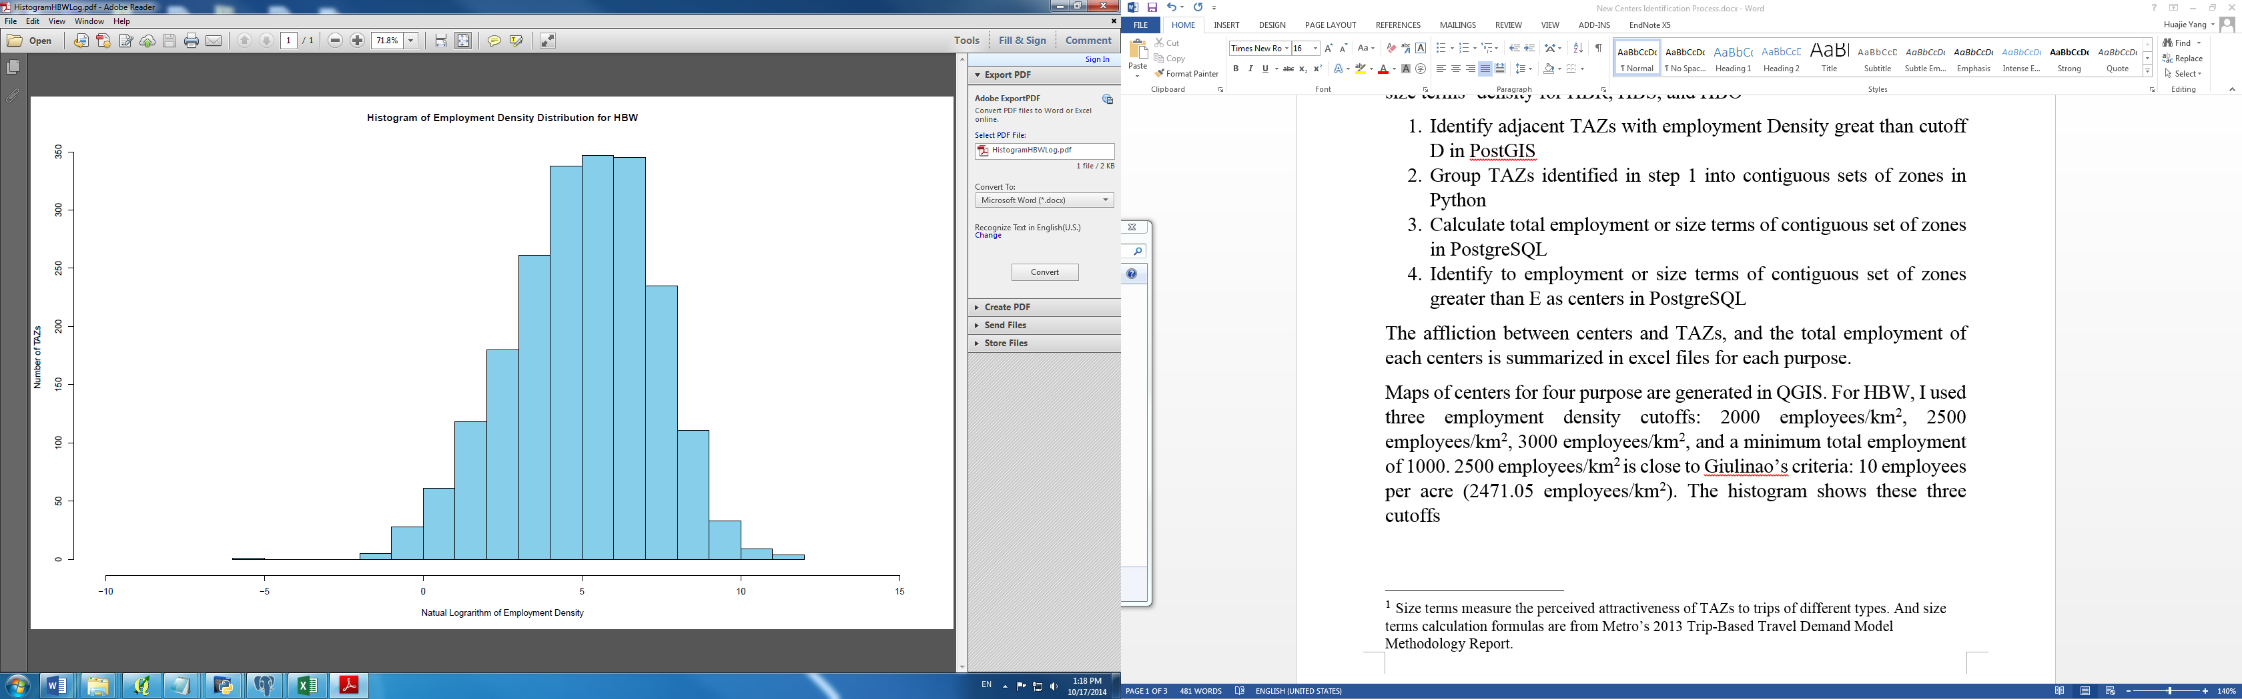

Fig. 1. Employment density distribution of HBW

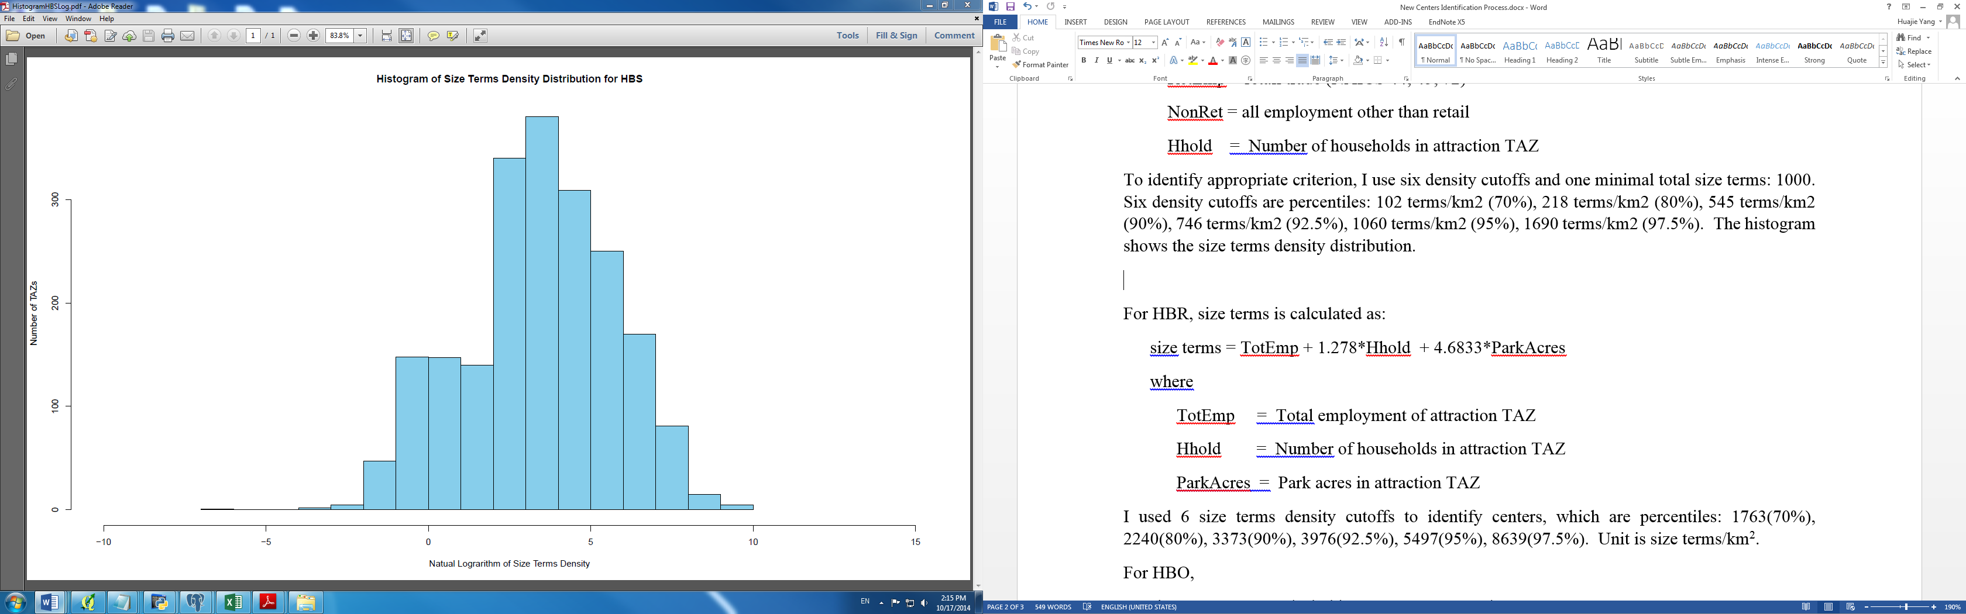

Fig. 2. Size terms density distribution of HBS

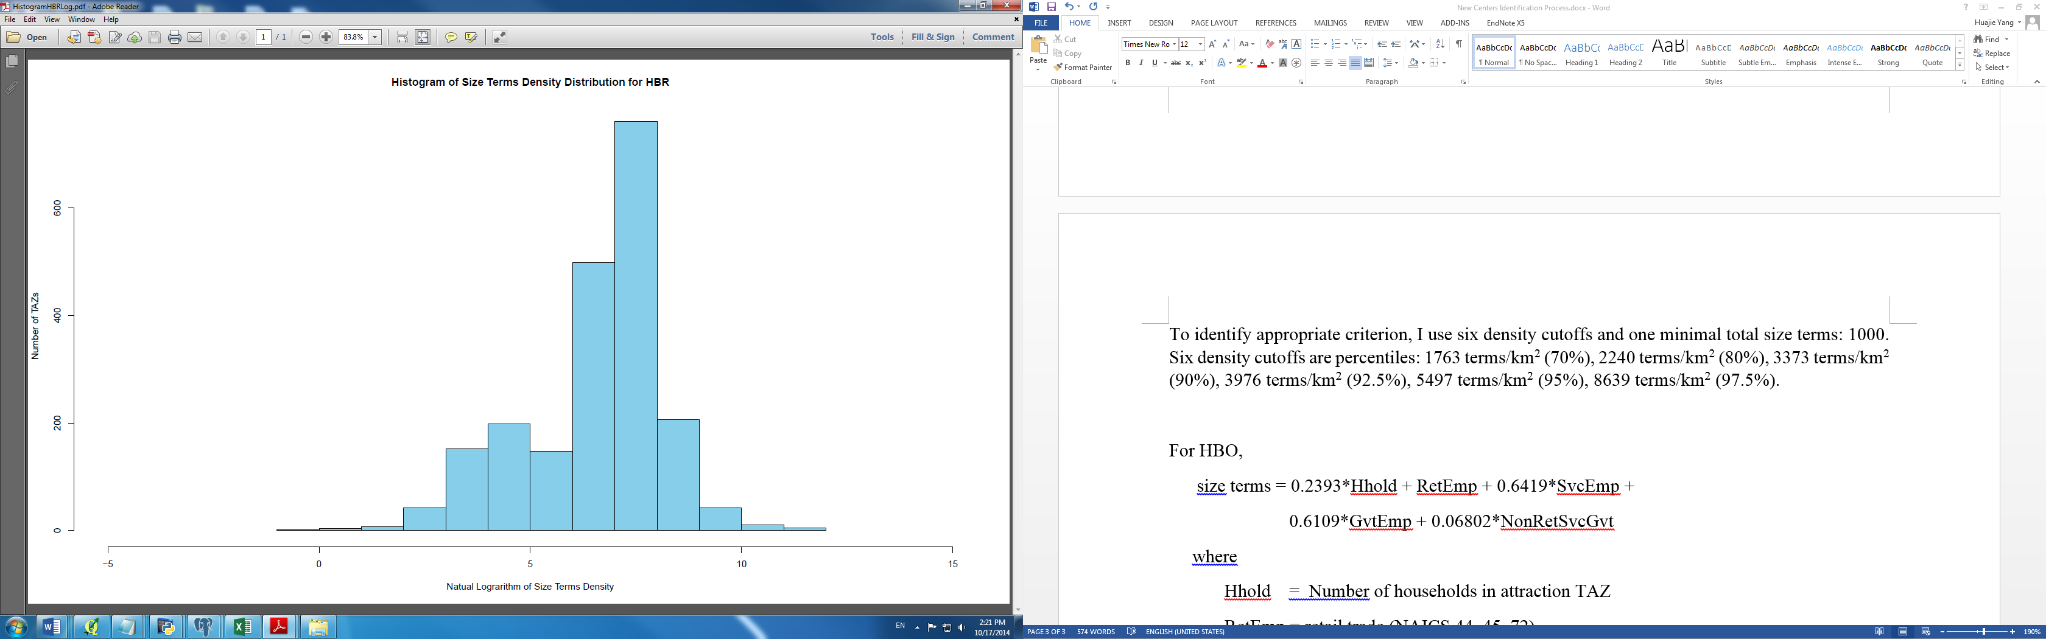

Fig. 3. Size terms density distribution of HBR

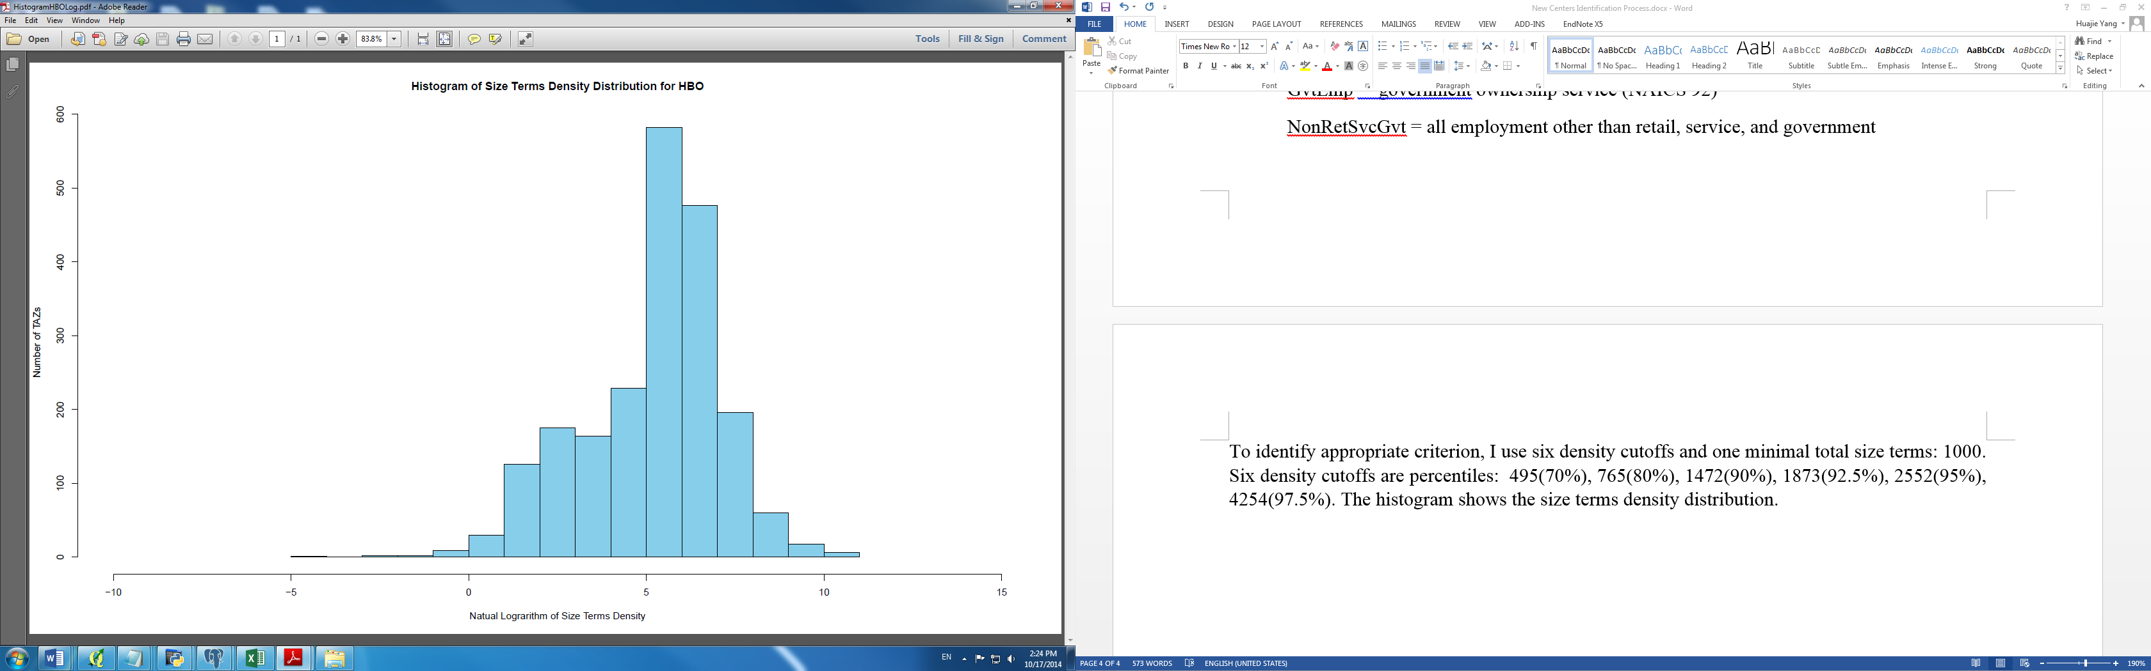

Fig. 4. Size terms density distribution of HBO

After analyzing the histogram above and comparing results of different cutoffs, cutoffs used in this study are identified and shown in table 1.

Tab. 1 Cutoffs for trip purposes

|  |  |  |  |  |
| --- | --- | --- | --- | --- |
|  | HBW | HBS | HBR | HBO |
| Density cutoff | 2500 employment/km2 | 102 sizeterms/km2 | 1763 sizeterms/km2 | 495 sizeterms/km2 |
| Total cutoff | 1000 employment | 1000 sizeterms | 1000 sizeterms | 1000 sizeterms |

All processes in this step are completed in two R script file: 3_identify_cluster.R.

4. Calculate trip probabilities and trips by mode

This step calculates trip probabilities and trips by mode, which are calculated as follows:

where

*MTpikjm* is the number of trips of income group *i* from TAZ *k* to TAZ *j* for trip purpose p by mode *m*

*MTpikj* is the number of trips of income group *i* for trip purpose from TAZ *k* to TAZ *j*

*MPpikjm* is the probability that mode m is used by income group *i* for trip purpose *p* from TAZ *k* to TAZ *j*

*Upikjm* is the utility for traveling by mode *m* between TAZ *k* and *j* for purpose p by income group *i*

All process of this step is completed in 4_cal_md_trips_probs.R.

5. Calculate travel time

This step calculates travel time from generation TAZ to TAZ of centers. Two methods are developed to calculate travel time to centers. First method calculates the minimal travel time from generation TAZ to TAZs of centers. Second method calculates the weighted average travel time from generation TAZ to TAZs of centers, weighting by trips from generation TAZ to TAZs of centers.

All process of this step is completed in 5_cal_travel_time.

6. Calculate monetary cost of travel time

Travel time costs of different modes are estimated with different percentage of 2011 Oregon Hourly Median Household Income (ODOT, 2012). Table 2 shows the percentage used for travel modes.

Tab. 2 Travel Time Cost Relative to 2011 Oregon Hourly Median Household Income

|  |  |  |  |  |  |  |  |
| --- | --- | --- | --- | --- | --- | --- | --- |
| Mode | driveAlone | drivePass | pass | busWalk | parkAndRideBus | bike | walk |
| Percentage | 50% | 50% | 35% | 35% | 35% | 50% | 50% |

All processes of this step are completed in R script file: 6_cal_time_cost.R.

7. Aggregate cost

There are two steps to aggregate travel time cost. First step aggregates them by weighting costs for each mode by the possibilities of using the mode from generation TAZ to TAZ of centers. Second step aggregates travel time costs by purposes and group income.

All processes of this step are completed in R script file: 7_agg_cost.R

**References**:

Giuliano, G., & Small, K. A. (1991). Subcenters in the Los Angeles region.*Regional science and urban economics*, *21*(2), 163-182.

Oregon Department of Transportation (2012). The Value of Travel-Time: Estimates of the Hourly Value of Time for Vehicles in Oregon 2011. Retrieved from <http://www.oregon.gov/ODOT/TD/TP/Reports/Value_of_TravelTime2011.pdf>

1. Sizeterms measure the perceived attractiveness of TAZs to trips of different types. And size terms calculation formulas are from Metro’s 2013 Trip-Based Travel Demand Model Methodology Report.